OUTPUT FILE :
- DATABASE STORED IN TABULAR FORM
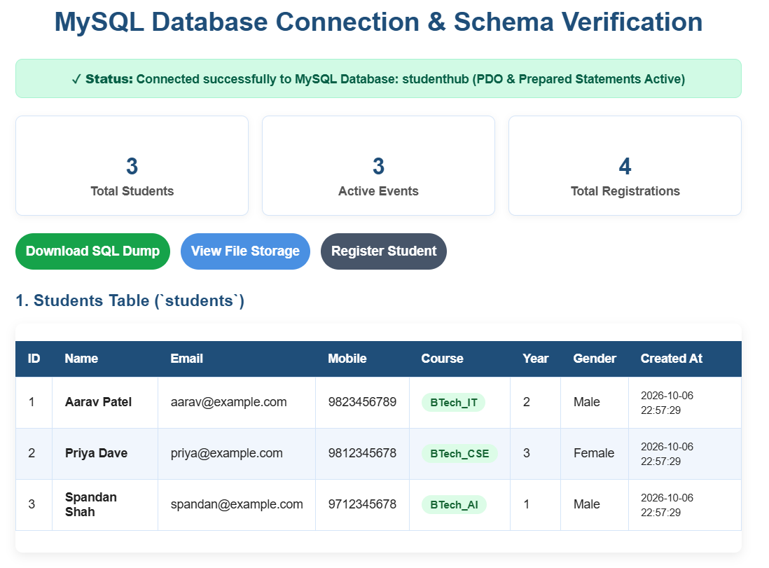
2)Register form
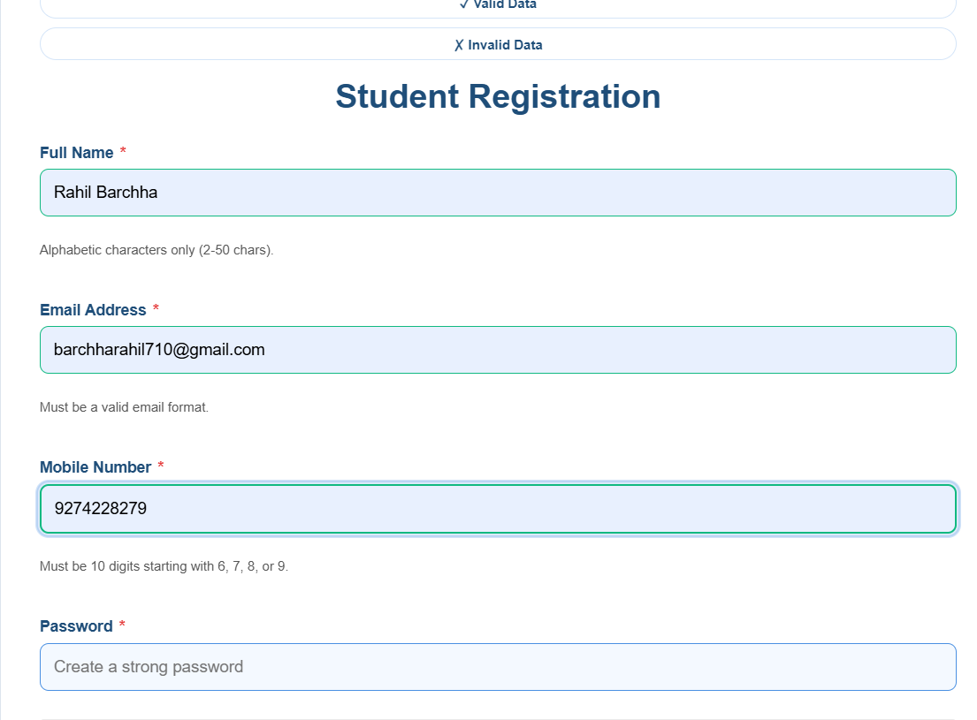

3)Data base
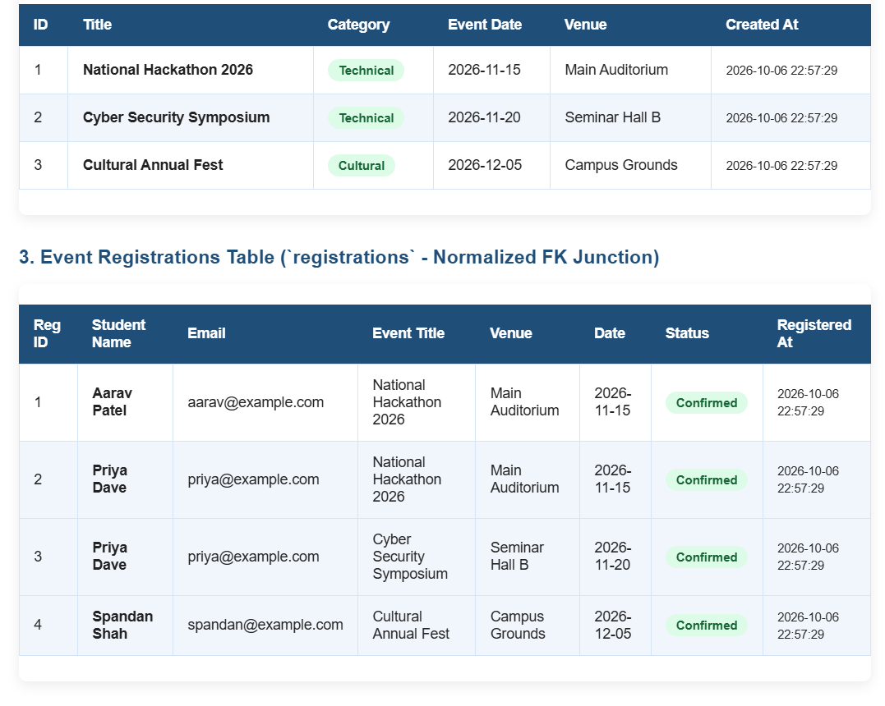

Github Link : https://github.com/Shreyansh2210/Web-Devlopment/tree/main

